mBackup Android Application
Software Requirement Specifications

Version 1.0

Class Name | Android Mobile Programming
Class Code | Android K15
Group | mBackup K15
Teacher | Khanh Nguyen, Tan Nguyen
Project Manager | Khanh Nguyen
Assign Date | July 08, 2011
Complete Date | Sept 19, 2011
Author | mBackup K15 Group
Version | 1.0
Approved By
Approved Date

Table of Contents
1. Introduction 3
1.1 Purpose 3
1.2 Scope 3
1.3 Definitions, Acronyms and Abbreviations 3
1.4 References 3
2. OVERAL Description 3
2.1 Product Perspective 3
2.2 Product Features 3
2.3 User Documents 4
2.4 Constraints 4
3. Use case model 4
3.1 The Actors 4
3.2 The use cases 4
3.3 Use cases diagram 5
4. Functional Requirements 10
4.1 Feature Backup and Restore Contact 10
4.1.1 Use case Backup Contact to SD Card (MBK_UC_1.1) 10
4.1.2 Use case Backup Contact to Server (MBK_UC_1.2) 11
4.1.3 Use case Backup Contact to Email (MBK_UC_1.3) 13
4.1.4 Restore Contact (MBK_UC_1.4) 14
4.1.5 Schedule Contact Backup (MBK_UC_1.5) 16
4.2 Feature Backup and Restore Images 17
4.2.1 Use case Display all images (MBK_UC_2.1) 17
4.2.2 Use case Zip images (MBK_UC_2.2) 17
4.2.3 Use case Backup images to SD card (MBK_UC_2.3) 18
4.2.4 Restore Images (MBK_UC_2.4) 19
4.3 Feature Backup and Restore SMS 20
4.3.1 Use case Backup SMS to SD Card (MBK_UC_3.1) 21
4.3.2 Use case Backup SMS to Server (MBK_UC_3.2) 22
4.3.3 Use case Backup SMS to Email (MBK_UC_3.3) 23
4.3.4 Restore SMS (MBK_UC_3.4) 25
4.3.5 Schedule SMS Backup (MBK_UC_3.5) 26
4.4 Feature Backup and Restore Use BackupAgent 27
4.4.1 Use case Backup data to Cloud (MBK_UC_4.1) 27
4.4.2 Restore use BackupAgent (MBK_UC_4.2) 28
4.4.3 Schedule Backup using Backup Agent (MBK_UC_4.3) 30

Introduction
The project to be devoloped is an android application that helps users to backup and restores data of phonebook, images, SMS in case users lost phone or lost data. In addition, the application can schedule or automatically capture picture and get location, lock phone to track the phone if users lost it.

Purpose
This Software Requirements Specification provides a complete description of all the functions and constraints of the mBackup project. The mBackup project will be implemented based on Java Language for Android and run on any Android OS version 2.0 or higher.

Scope
The scope of the project is targeted to the client application on an Android mobile phone.

Definitions, Acronyms and Abbreviations
Term | Definitions, Acronyms and Abbreviations
OS | Operating System
mBackup | Mobile Backup
SDE | Smart Development Environment
ATD | Android Development Tools

References
- SRS mBackup_contact.doc by Hung Pham
- SRS mBackup_SMS.doc by Thuong Le
- SRS mBackup_Agent.doc by An Le
- SRS mBackup.doc by Danh Huynh

OVERAL Description

Product Perspective
This mBackup project is a new seft-contained product. It will be implemented as an application run on an Android OS version 2.0 or higher.
This application will be developed on Eclipse SDE with ATD plug-in, base on java language for Android.

Product Features
Following main features will be made available for the applicaton. The features’ detail will be described at “System Features” section.
- Backup and restore contacts
- Backup and restore SMS.
- Backup and restore images
- Backup and restore using Backup Agent.

User Documents
The following documents will be made available to users:
- Installation guide
- User guide/document

Constraints
This application can run only on Android OS version 2.0 or higher.

Use case model

The Actors
Administrator: the webservice which provides method to track the phone and stores backup data.
User: person who uses an Android Phone.

The use cases
A Use Case is a description of a complete flow of events that results in something of value to an Actor.
System Features | Main Use Case | Use Case ID
Backup and Restore Contacts
 | Backup contact to SD card | MBK_UC_1.1
 | Backup contact to server | MBK_UC_1.2
 | Backup contact to Email | MBK_UC_1.3
 | Restore contacts | MBK_UC_1.4
 | Schedule to backup Contact | MBK_UC_1.5
Backup and Restore Images
 | Dislay all images | MBK_UC_2.1
 | Zip all images to a zip files | MBK_UC_2.2
 | Backup images to sdcard | MBK_UC_2.3
 | Restore images form zip file | MBK_UC_2.4
Backup and Restore SMS
 | Backup SMS to SD card | MBK_UC_3.1
 | Backup SMS to server | MBK_UC_3.2
 | Backup SMS to Email | MBK_UC_3.3
 | Restore SMS data | MBK_UC_3.4
 | Schedule to backup SMS | MBK_UC_3.5
Backup and Restore using Backup Agent
 | Backup data to cloud | MK_UC_4.1
 | Start a new backup | MK_UC_4.1.1
 | Browser backup file in SD card for saving to cloud | MK_UC_4.1.2
 | Set up scheduling | MK_UC_4.1.3
 | Start progress & view status or stop backup | MK_UC_4.1.4
 | View backup history | MK_UC_4.1.5
 | Restore using BackupAgent | MK_UC_4.2
 | Start a new restore | MK_UC_4.2.1
 | Read data which you backup | MK_UC_4.2.2
 | Start progress, view status or Stop Restore | MK_UC_4.2.3
 | View restore history | MK_UC_4.2.4
 | Schedule to Backup | MK_UC_4.3

Use cases diagram
Backup and Restore Contacts
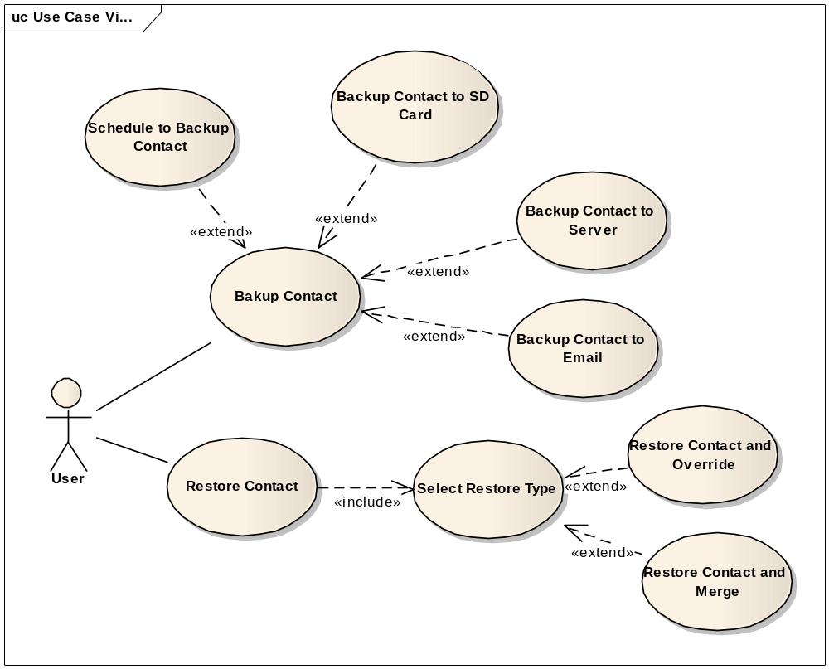

Backup And Restore Images
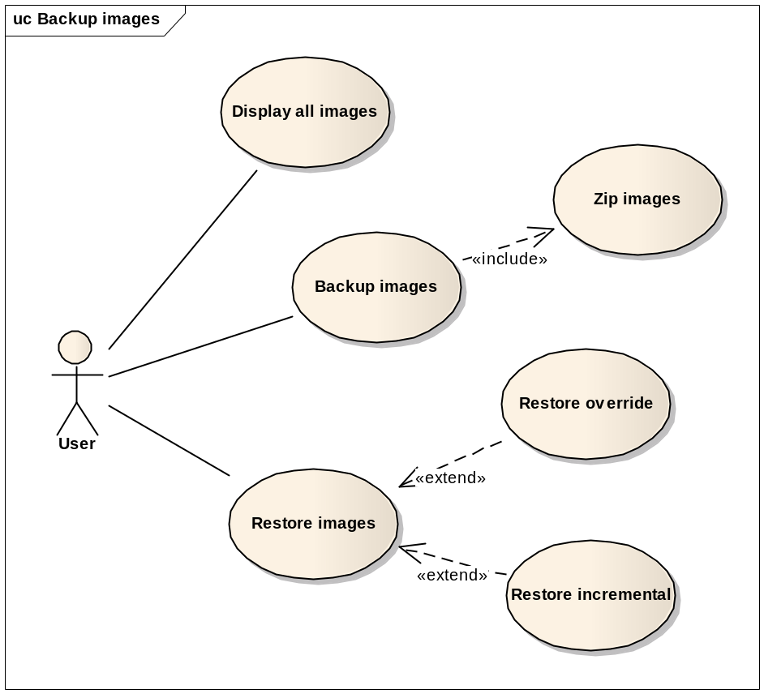

Backup and Restore SMS, MMS
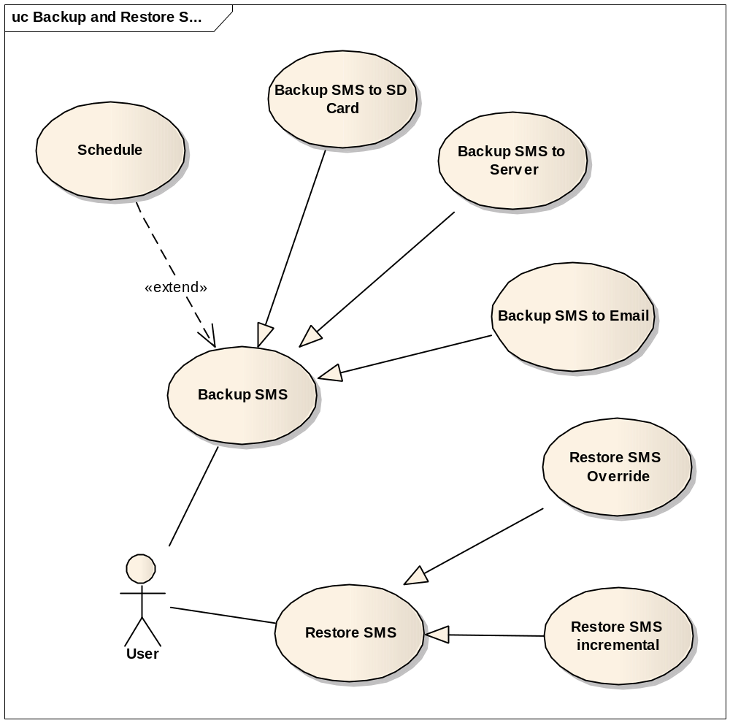
Backup and Restore using Backup Agent
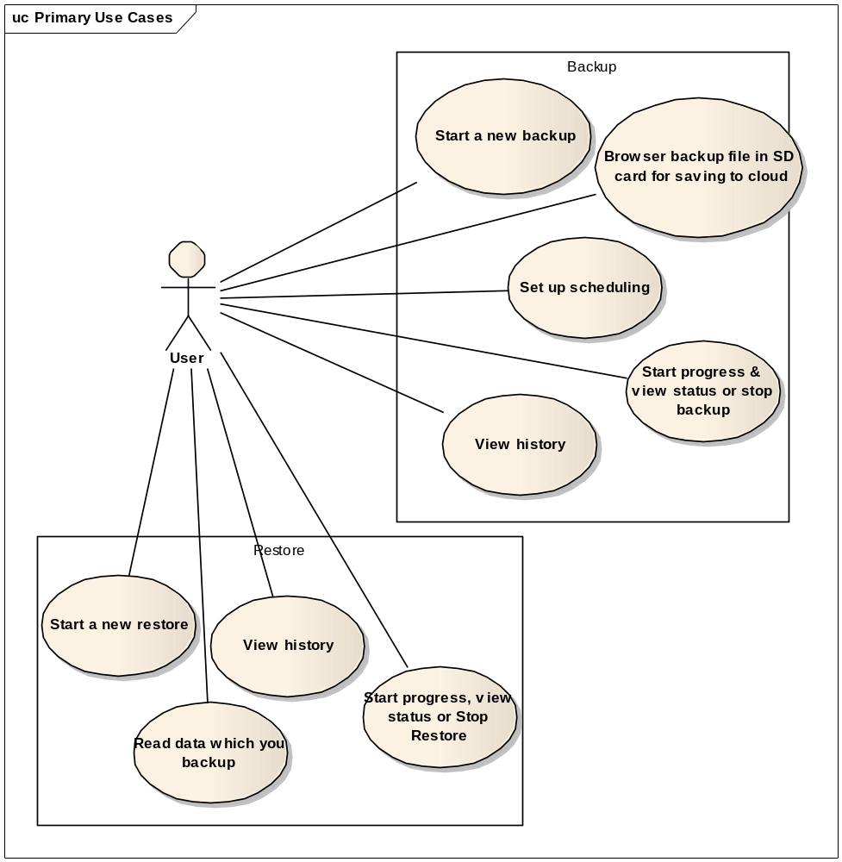

Functional Requirements

Feature Backup and Restore Contact

Use case Backup Contact to SD Card (MBK_UC_1.1)
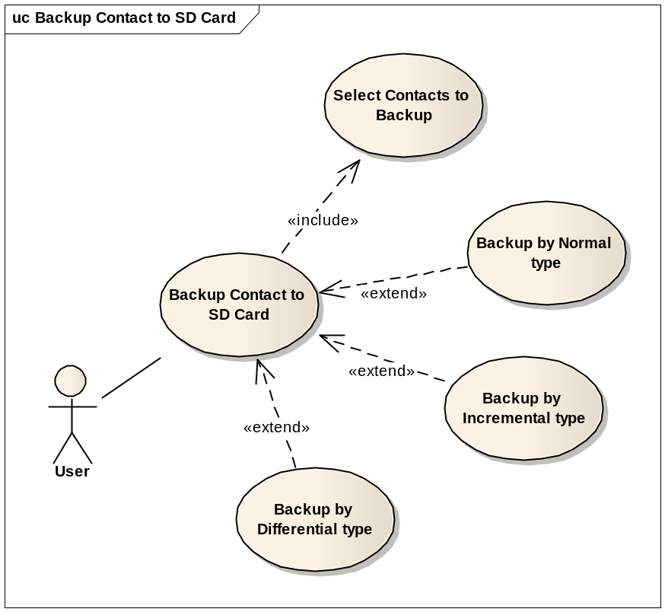
Use Case ID | MBK_UC_1.1
Name | Backup Contact to SD Card
Goal | Backup all or some contacts which selected and save to SD Card as a file
Actors | User
Include | Select contacts to backup
Extended | Backup by Normal type  Backup by Incremental type  Backup by Differential type
Pre-conditions | - All or some contacts are selected.  - SD card has enough memory to save file.
Post-conditions | - A backup file will be stored in SD card.
Main Flow | - Select Backup Contact to SD Card function
Main Flow | - Select Backup Contact to SD Card function | - Display edit-texts to enter file name and descriptions.
Main Flow | - Enter file name
Main Flow |  | - Display processes, remaining time.  - Read contacts data and create a file to save them all.  - Write data file to SD card.  - Show the finish dialog.
Main Flow | - Confirm the finish dialog
Exceptions | 4.A: If SD card is not enough memory, stop all processes and remind user to delete files to get more space.  6.A: If it’s impossible to write file to SD card, remind user to get permissions from settings.
Open Issues | N/A

Use case Backup Contact to Server (MBK_UC_1.2)
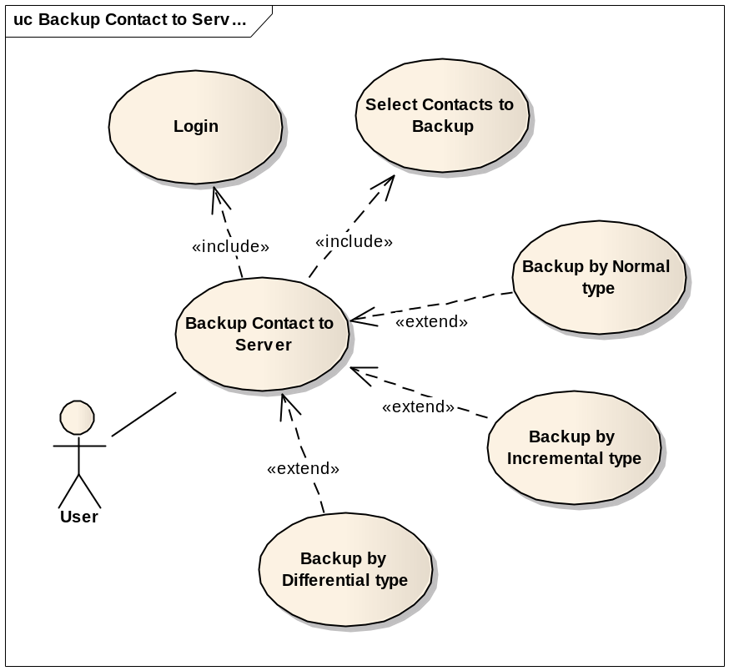

Use Case ID | MBK_UC_1.2
Name | Backup Contact to Server
Goal | Backup all or some contacts data and save on a server.
Actors | User
Include | Select contacts to backup  Login
Extended | Backup by normal type  Backup by incremental type  Backup by differential type
Pre-conditions | - All or some contacts are selected.  - SD card has enough memory to save file.  - There is internet connection  - Login with an registered account
Post-conditions | - A new backup version will be created on server
Main Flow | - Select Backup Contact to Server function
Main Flow | - Select Backup Contact to Server function | - Display an edit-text to enter descriptions of the backup version.
Main Flow | - Enter descriptions
Main Flow |  | - Connect to server, Display processes, remaining time.  - Read data of selected contacts and create a file to upload to server.  - Upload data file to server.  - Show the finish dialog.
Main Flow | - Confirm the finish dialog
Exceptions | 1.A: If user is not currently logged-in, show log-in form.  4.A: If internet connection is failed, remind user to get an internet connection.
Open Issues | N/A

Use case Backup Contact to Email (MBK_UC_1.3)
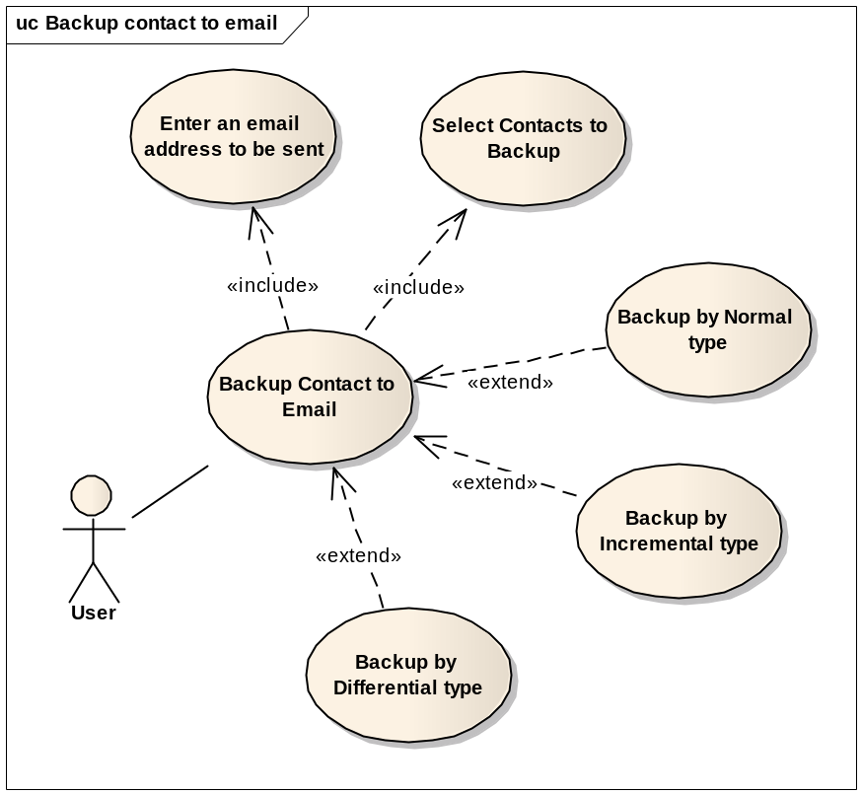

Use Case ID | MBK_UC_1.3
Name | Backup Contact to Email
Goal | Backup all or some contacts and send to an email account.
Actors | User
Include | Select contacts to backup  Enter an email account to be sent
Extended | Backup by normal type  Backup by incremental type  Backup by differential type
Pre-conditions | - All or some contacts are selected.  - SD card has enough memory to save file.  - There is internet connection  - Enter an email address to be sent
Post-conditions | A backup file will be sent to an email address
Main Flow | - Select Backup Contact to Server function
Main Flow | - Select Backup Contact to Server function | - Display an edit-text to enter descriptions of the backup version.
Main Flow | - Enter descriptions
Main Flow |  | - Display processes, remaining time.  - Read selected contact data and create a backup file  - Attach backup file and send to an email address.  - Show the finish dialog.
Main Flow | - Confirm the finish dialog
Exceptions | 4.A1: If internet connection is failed, remind user to get an internet connection.  4.A2. If email account has not been entered in the Settings yet, show the Settings.
Open Issues | N/A

Restore Contact (MBK_UC_1.4)
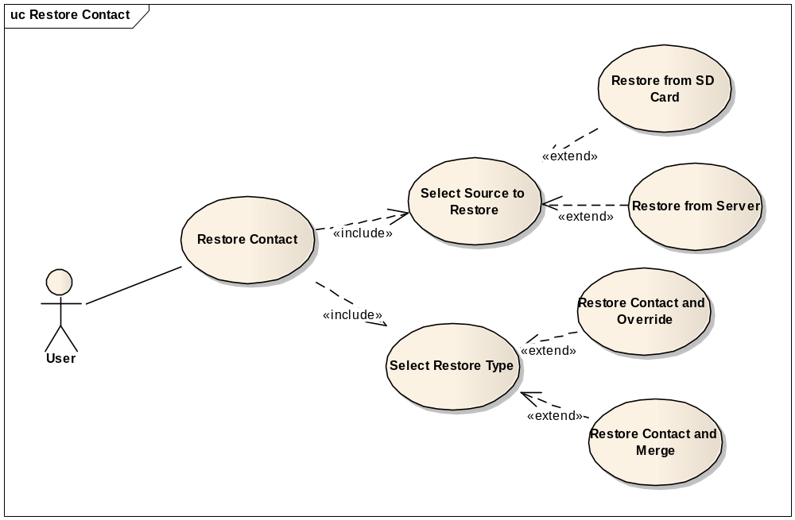
Use Case ID | MBK_UC_1.4
Name | Restore Contact
Goal | Restore Contact from SD card or server
Actors | User
Include | Select source to restore  Select restore type
Extended | N/A
Pre-conditions | - The backup version is available  - There is internet connection if restore from server.
Post-conditions | Contact data on user’s phone will be restored
Main Flow | - Select Restore Contact function
Main Flow | - Select Restore Contact function | - Display select backup source options
Main Flow | - Select backup source
Main Flow |  | - Display backup versions
Main Flow | - Select a version
Main Flow |  | - Display select restore method options
Main Flow | - Select restore method
Main Flow |  | - Run the selected restore function.  - Show processes, time remaining.  - Show the finish dialog
Main Flow | - Confirm the finish dialog
Exceptions | 2.A: If server source is selected, check the internet connection.  4.A: If there are no backup versions available, end the use-case.  6.A: If override method is selected, the old Contact data will be deleted.  8.A1: If server source is selected, connect to the server, down load backup file and restore to the phone.  8.A2: If SD card source is selected, read the backup file from SD card and restore to the phone
Open Issues | N/A

Schedule Contact Backup (MBK_UC_1.5)
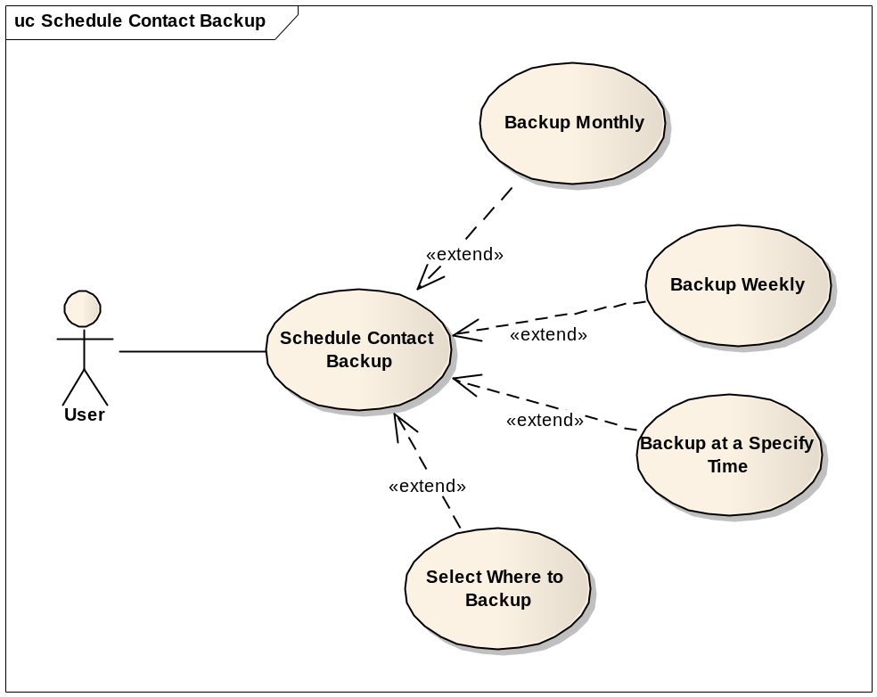

Use Case ID | MBK_UC_1.5
Name | Schedule Contact Backup
Goal | Schedule what time the Contact data will be automatically backed up.
Actors | User
Include | N/A
Extended | Backup monthly  Backup weekly  Backup at a specify time  Choose where to store
Pre-conditions | N/A
Post-conditions | Application will run the backup Contact data function automatically at the scheduled time
Main Flow | - Select the Schedule Contact Backup function
Main Flow | - Select the Schedule Contact Backup function | - Display the Schedule form
Main Flow | - Select time to backup automatically  - Select where to backup to  - Press “save settings” button.
Main Flow |  | - Save the schedule.
Exceptions | 4.A: If “backup to server” is selected, ensure that the phone has an internet connection.
Open Issues | N/A

Feature Backup and Restore Images

Use case Display all images (MBK_UC_2.1)
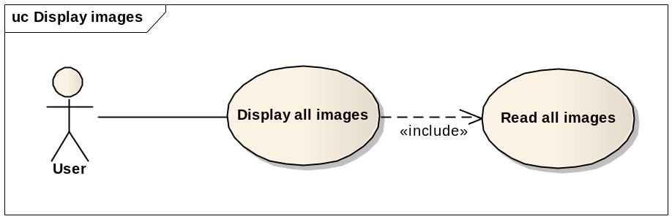
Use Case ID | MBK_UC_2.1
Name | Display all images
Goal | Display all images on the phone
Actors | User
Include | Read all images
Extended
Pre-conditions | Backup images function is selected
Post-conditions | Display all images on the phone to a gridview
Main Flow | - Select Backup Images function
Main Flow | - Select Backup Images function | - Display three options: display images, backup and restore images
Main Flow | - Choose display images
Main Flow |  | - Display progress bar for loading images.  - Read and display images.
Exceptions | 5.A1: If there is no images on the phone, show “emty image” message  5.A:2 If there are so much images, list images by catalog.
Open Issues | N/A

Use case Zip images (MBK_UC_2.2)

Use Case ID | MBK_UC_2.2
Name | Zip images
Goal | Zip all images to a zip file
Actors | User
Include | N/A
Extended | N/A
Pre-conditions | SD card has enough memory
Post-conditions | A zip file to archive all images will be created
Main Flow | - Select Backup Images function
Main Flow | - Select Backup Images function | - Display three options: display images, backup and restore images.
Main Flow | - Choose Backup function
Main Flow |  | - Show progress bar  - Read all images  - Check the sd card memory  - Zip all images to a zip file  - Show finished dialog
Exceptions | 6.A: If sd card does not have enough memory, warning user to get more space.
Open Issues | N/A

Use case Backup images to SD card (MBK_UC_2.3)
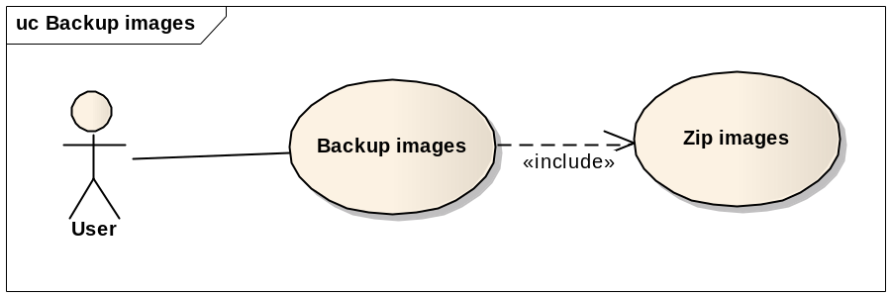

Use Case ID | MBK_UC_2.3
Name | Backup Images to SD card
Goal | Save zipped file to SD card
Actors | User
Include | Zip images
Extended | N/A
Pre-conditions | Finished zipping images successfully.
Post-conditions | Save zip file to SD card
Main Flow | - Select Backup Images function
Main Flow | - Select Backup Images function | - Display three options: display images, backup and restore images.
Main Flow | - Choose Backup function
Main Flow |  | - Show progress bar  - Check the sd card memory  - Save zip file to SD card  - Show finished dialog
Main Flow | - Confirm the finish dialog
Exceptions | 5.A. If sd card does not have enough memory, warning user to get more space.
Open Issues | N/A

Restore Images (MBK_UC_2.4)
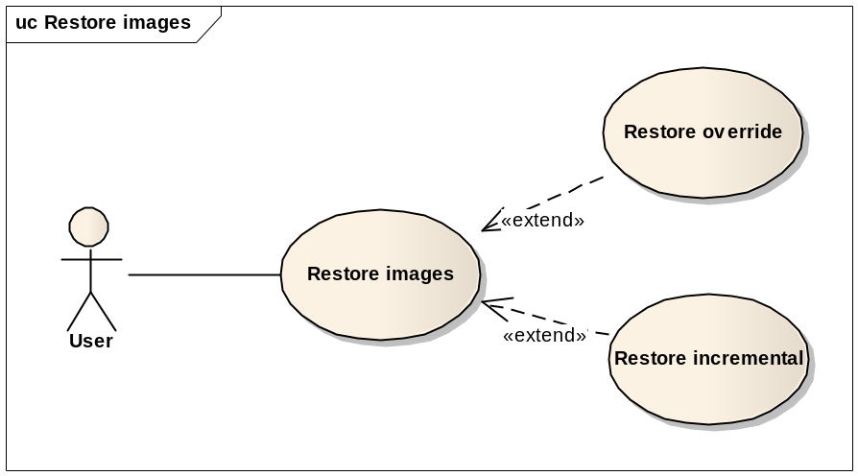
Use Case ID | MBK_UC_2.4
Name | Restore Images
Goal | Restore all images from zip file
Actors | User
Include | N/A
Extended | - Restore override  - Restore incremental
Pre-conditions | - A zip file is backed up on sd card  - SD card has enough memory to restore images
Post-conditions | Images will be restore to the phone
Main Flow | - Select Backup Images function
Main Flow | - Select Backup Images function | - Display three options: display images, backup and restore images.
Main Flow | - Choose Restore function
Main Flow |  | - Get all versions (zip files on sd card)
Main Flow | - Select a version
Main Flow |  | - Show progress bar  - Check the sd card memory  - Unzip and restore all images to the phone  - Show finished dialog
Exceptions | 7.A. If sd card does not have enough memory, warning user to get more space.
Open Issues | N/A

Feature Backup and Restore SMS

Use case Backup SMS to SD Card (MBK_UC_3.1)
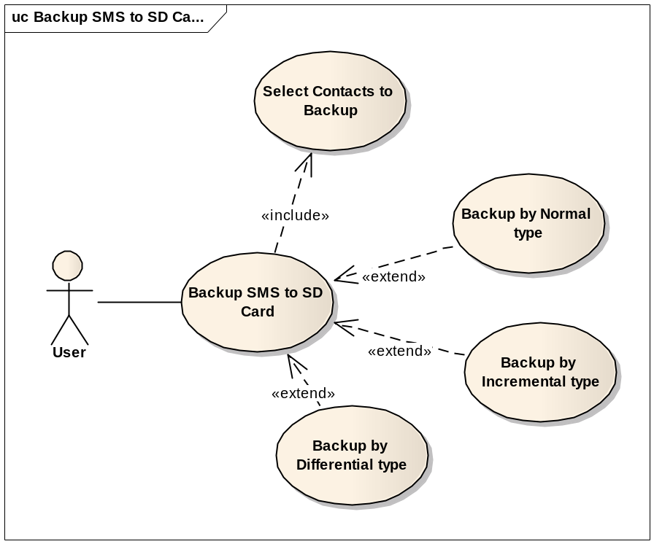
Use Case ID | MBK_UC_3.1
Name | Backup SMS to SD Card
Goal | Backup all or some SMSs which is selected and save to SD Card as a file
Actors | User
Include | Select SMSs to backup
Extended | Backup by Normal type  Backup by Incremental type  Backup by Differential type
Pre-conditions | - All or some SMSs are selected.  - SD card has enough memory to save file.
Post-conditions | - A backup file will be stored in SD card.
Main Flow | - Select Backup SMS to SD Card function
Main Flow | - Select Backup SMS to SD Card function | - Display edit-texts to enter file name and descriptions.
Main Flow | - Enter file name
Main Flow |  | - Display processes, remaining time.  - Read SMSs and create a file to save them all.  - Write data file to SD card.  - Show the finish dialog.
Main Flow | - Confirm the finish dialog
Exceptions | 4.A: If SD card is not enough memory, stop all processes and remind user to delete files to get more space.  6.A: If it’s impossible to write file to SD card, remind user to get permissions from settings.
Open Issues | N/A

Use case Backup SMS to Server (MBK_UC_3.2)
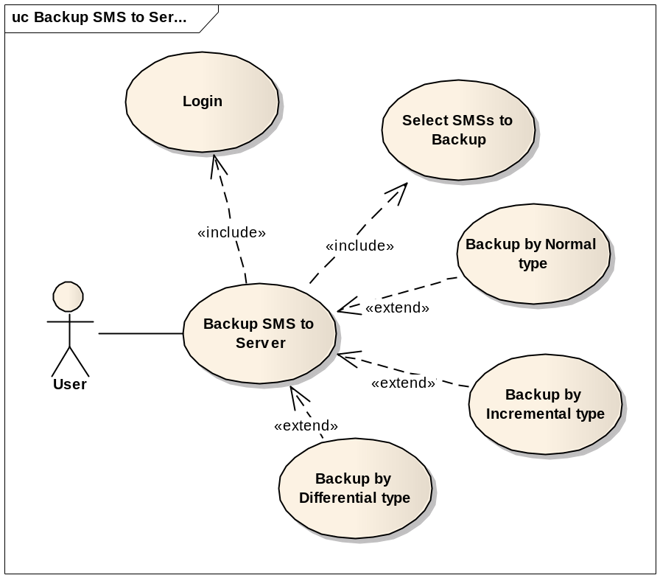

Use Case ID | MBK_UC_3.2
Name | Backup SMS to Server
Goal | Backup all or some SMSs data and save on a server.
Actors | User
Include | Select SMSs to backup  Login
Extended | Backup by normal type  Backup by incremental type  Backup by differential type
Pre-conditions | - All or some SMSs are selected.  - SD card has enough memory to save file.  - There is internet connection  - Login with an registered account
Post-conditions | - A new backup version will be created on server
Main Flow | - Select Backup SMS to Server function
Main Flow | - Select Backup SMS to Server function | - Display an edit-text to enter descriptions of the backup version.
Main Flow | - Enter descriptions
Main Flow |  | - Connect to server, Display processes, remaining time.  - Read data of selected SMSs and create a file to upload to server.  - Upload data file to server.  - Show the finish dialog.
Main Flow | - Confirm the finish dialog
Exceptions | 1.A: If user is not currently logged-in, show log-in form.  4.A: If internet connection is failed, remind user to get an internet connection.
Open Issues | N/A

Use case Backup SMS to Email (MBK_UC_3.3)
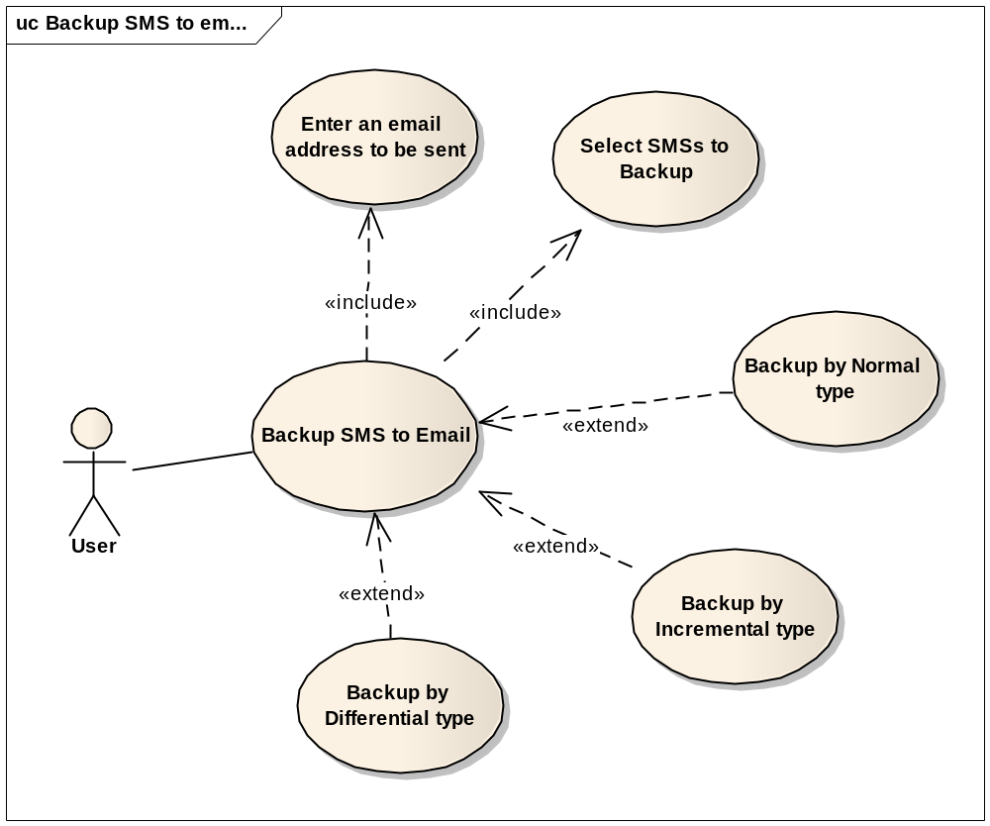

Use Case ID | MBK_UC_3.3
Name | Backup SMS to Email
Goal | Backup all or some SMSs and send to an email account.
Actors | User
Include | Select SMSs to backup  Enter an email account to be sent
Extended | Backup by normal type  Backup by incremental type  Backup by differential type
Pre-conditions | - All or some SMSs are selected.  - SD card has enough memory to save file.  - There is an internet connection  - Enter an email address to be sent
Post-conditions | A backup file will be sent to an email address
Main Flow | - Select Backup SMS to Server function
Main Flow | - Select Backup SMS to Server function | - Display an edit-text to enter descriptions of the backup version.
Main Flow | - Enter descriptions
Main Flow |  | - Display processes, remaining time.  - Read selected SMS data and create a backup file  - Attach backup file and send to an email address.  - Show the finish dialog.
Main Flow | - Confirm the finish dialog
Exceptions | 4.A1: If internet connection is failed, remind user to get an internet connection.  4.A2. If email account has not been entered in the Settings yet, show the Settings.
Open Issues | N/A

Restore SMS (MBK_UC_3.4)
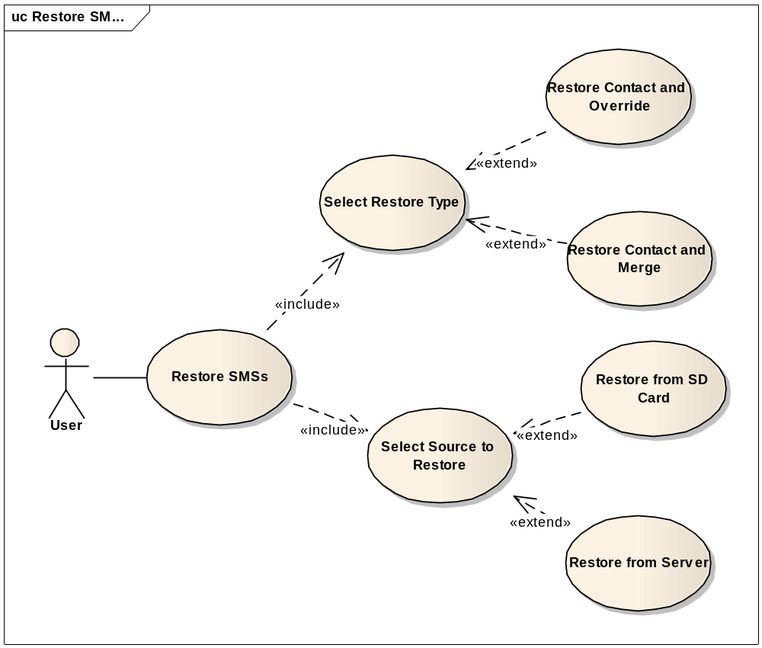
Use Case ID | MBK_UC_3.4
Name | Restore SMS
Goal | Restore SMS from SD card or server
Actors | User
Include | Select source to restore  Select restore type
Extended | N/A
Pre-conditions | - The backup version is available  - There is internet connection if restore from server.
Post-conditions | SMS data on user’s phone will be restored
Main Flow | - Select Restore SMS function
Main Flow | - Select Restore SMS function | - Display select backup source options
Main Flow | - Select backup source
Main Flow |  | - Display backup versions
Main Flow | - Select a version
Main Flow |  | - Display select restore method options
Main Flow | - Select restore method
Main Flow |  | - Run the selected restore function.  - Show processes, time remaining.  - Show the finish dialog
Main Flow | - Confirm the finish dialog
Exceptions | 2.A: If server source is selected, check the internet connection.  4.A: If there are no backup versions available, end the use-case.  6.A: If override method is selected, the old SMS data will be deleted.  8.A1: If server source is selected, connect to the server, down load backup file and restore to the phone.  8.A2: If SD card source is selected, read the backup file from SD card and restore to the phone
Open Issues | N/A

Schedule SMS Backup (MBK_UC_3.5)
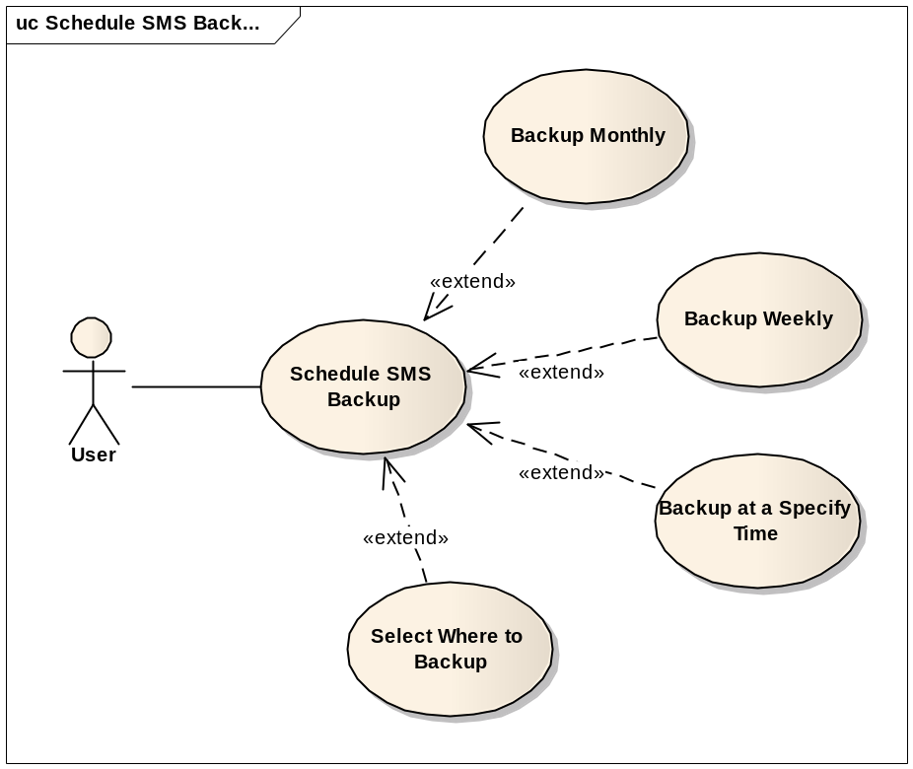

Use Case ID | MBK_UC_3.5
Name | Schedule SMS Backup
Goal | Schedule what time the SMS data will be automatically backed up.
Actors | User
Include | N/A
Extended | Backup monthly  Backup weekly  Backup at a specify time  Choose where to store
Pre-conditions | N/A
Post-conditions | Application will run the backup SMS data function automatically at the scheduled time
Main Flow | - Select the Schedule SMS Backup function
Main Flow | - Select the Schedule SMS Backup function | - Display the Schedule form
Main Flow | - Select time to backup automatically  - Select where to backup to  - Press “save settings” button.
Main Flow |  | - Save the schedule.
Exceptions | 4.A: If “backup to server” is selected, ensure that the phone has an internet connection.
Open Issues | N/A

Feature Backup and Restore Use BackupAgent

Use case Backup data to Cloud (MBK_UC_4.1)

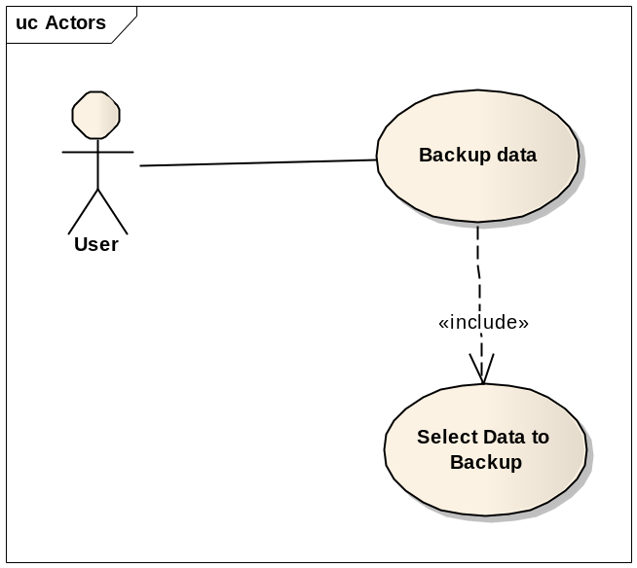

Use Case ID | MBK_UC_4.1
Name | Backup data to Cloud
Goal | Backup all data and save to Cloud
Actors | User
Include | Select Application
Extended | N/A
Pre-conditions | - Data which you want to backup is selected  - Has an internet connection for saving to Cloud
Post-conditions | A backup file will be stored on cloud
Main Flow | - Select Backup data to cloud function
Main Flow | - Select Backup data to cloud function | - Display edit-texts to enter file name and descriptions.
Main Flow | - Enter file name
Main Flow |  | - Display processes, remaining time.  - Read all Memo data and create a file to save them all.  - Save data file to cloud  - Show the finish dialog.
Main Flow | - Confirm the finish dialog
Exceptions | 4.A: If Internet is disconnected, stop all processes and remind user to delete files to get more space..
Open Issues | N/A

Restore use BackupAgent (MBK_UC_4.2)

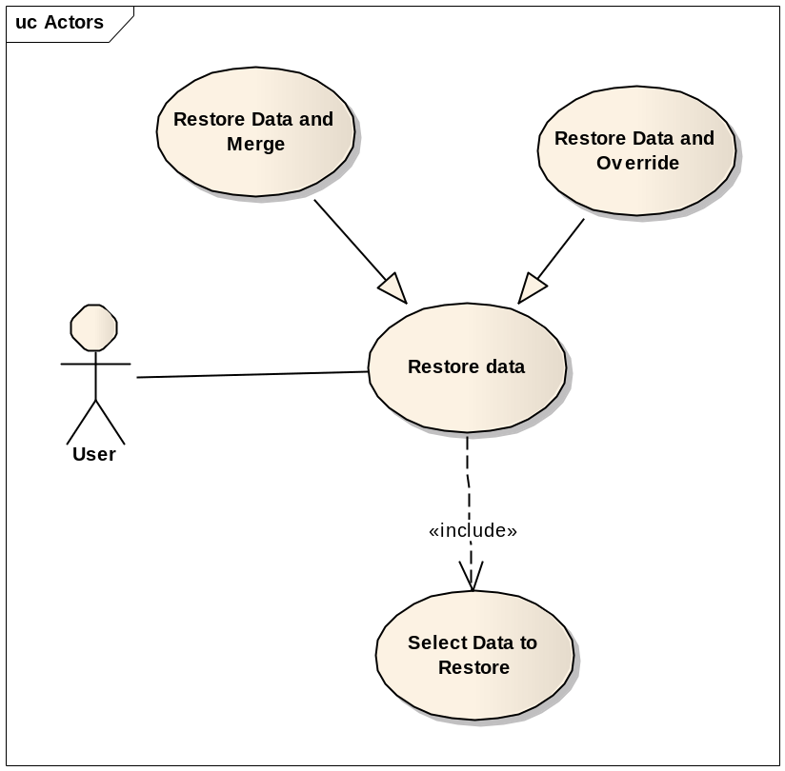

Use Case ID | MBK_UC_4.2
Name | Restore use BackupAgent
Goal | Restore Data from clound
Actors | User
Include | Select Application
Extended | N/A
Pre-conditions | - Data is selected  - Has an internet connection for restoring from Cloud
Post-conditions | Memo data on user’s phone will be restored
Main Flow | - Select Restore use BackupAgent function
Main Flow | - Select Restore use BackupAgent function | - Display select backup source options
Main Flow | - Select backup source
Main Flow |  | - Display backup versions
Main Flow |  | - Display select restore method options
Main Flow |  | - Run the selected restore function.  - Show processes, time remaining.  - Show the finish dialog
Main Flow | - Confirm the finish dialog
Exceptions | 2.A: If server source is selected, check the internet connection.  4.A: If there are no backup versions available, end the use-case.  6.A: If override method is selected, the old data will be deleted.  8.A1: If server source is selected, connect to the server, down load backup file and restore to the phone.
Open Issues | N/A

Schedule Backup using Backup Agent (MBK_UC_4.3)

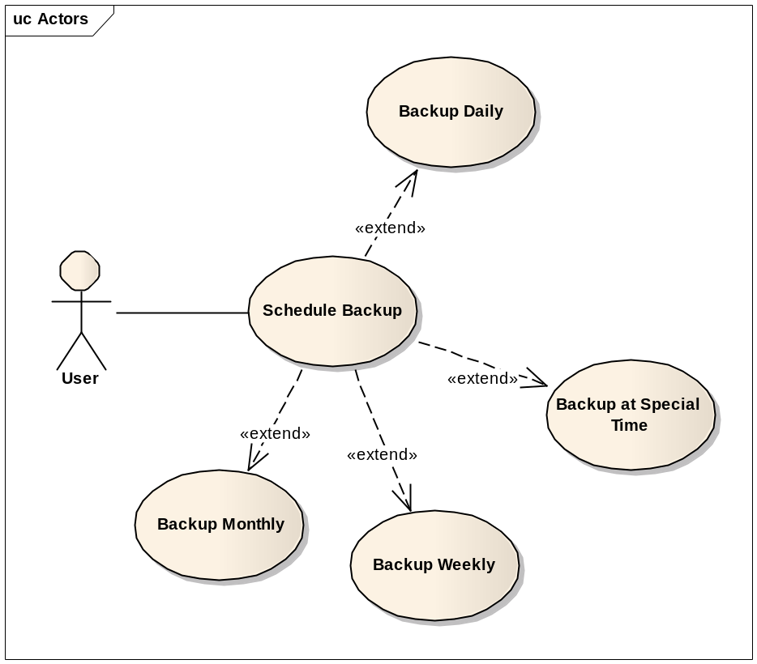

Use Case ID | MBK_UC_4.3
Name | Schedule Backup
Goal | Schedule what time the data will be automatically backed up.
Actors | User
Include | N/A
Extended | Backup monthly  Backup weekly  Backup at a specify time  Choose where to store
Pre-conditions | N/A
Post-conditions | Application will run the backup Memo data function automatically at the scheduled time
Main Flow | - Select the Schedule Memo Backup function
Main Flow | - Select the Schedule Memo Backup function | - Display the Schedule form
Main Flow | - Select time to backup automatically  - Select where to backup to  - Press “save settings” button.
Main Flow |  | - Save the schedule.
Exceptions | 4.A: If “backup to server” is selected, ensure that the phone has an internet connection.

---------- End of Document ----------

